**CST 2309 – EXAM # 2**

Lab – Exam 1

Student Name: Carlos A. Pico

CSS Exam Part 2

1. Click to Launch [Styling Web Forms](https://developer.mozilla.org/en-US/docs/Learn/Forms/Styling_web_forms)
2. Scroll down to display **A specific styling example**
3. Using the instructions (and code ) , create the form

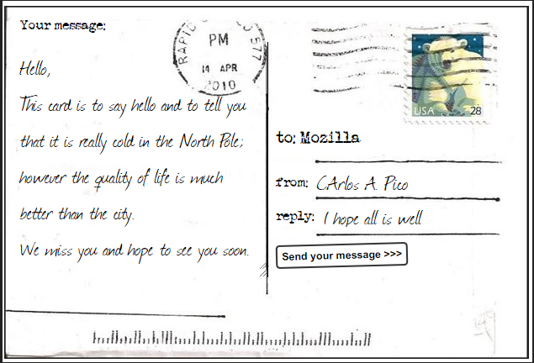

1. Name the form index.html.
2. Publish the form using GitHub Pages

Add the URL to the published site here:

Also, add the URL of the published form in the comment section of Blackboard

1. **Upload this worksheet to Blackboard**